Coming In June!
MVLP Tea Party

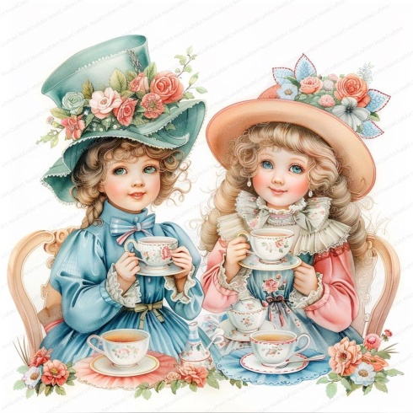
WHEN: Monday, June 15th (Monthly Luncheon)
TIME: 11:30 A.M. (Doors open at 11:00)
WHAT TO BRING: A teacup and saucer from your favorite China set. Have a favorite tea, welcome to bring.
WHAT TO WEAR: Dress up in your spring dress or pant suit. Top it off with a Kentucky Derby, Spring floral hat or fascinator!
SPECIAL FEATURE: Speaker – Saddlebrooke’s author Denise Gilliat-Norgard with her book “Pink Petals/Green Leaves” The story of one family’s journey west. (Copies will be available)
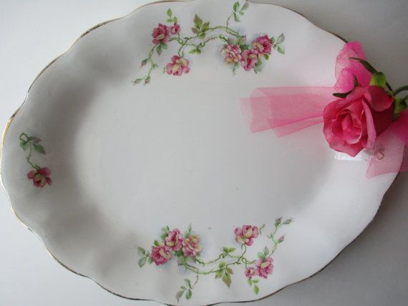
Enjoy a cup of tea with a variety of delectable “tea party” selections. Come join in the fun!
COST: $20 (Check placed in black box by Monday June 8th 2:00 p.m.)

